**LUNG DISEASES**

**Chronic bronchitis**

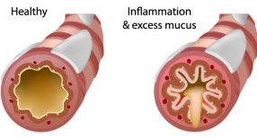Chronic bronchitis is a disease of the lung. The lungs consist of a series of folded membranes (the alveoli) which are located at the ends of very fine branching air passages (bronchioles). Chronic bronchitis is a persisting infection and inflammation of the larger airways of the lungs – the bronchi.

The cause of chronic bronchitis is usually long-term exposure to irritants that damage your lungs and airways. In the United States, cigarette smoke is the main cause. Pipe, cigar, and other types of tobacco smoke can also cause chronic bronchitis, especially if you inhale them. The risk factors for chronic bronchitis include:

Smoking. This the main risk factor. Up to 75 percent of people who have chronic bronchitis smoke or used to smoke.

Long-term exposure to other lung irritants, such as secondhand smoke, air pollution, and chemical fumes and dusts from the environment or workplace.

Age. Most people who have chronic bronchitis are at least 40 years old when their symptoms begin.

Genetics. This includes alpha-1 antitrypsin deficiency, which is a genetic condition. Also, smokers who get chronic bronchitis are more likely to get it if they have a family history of COPD.

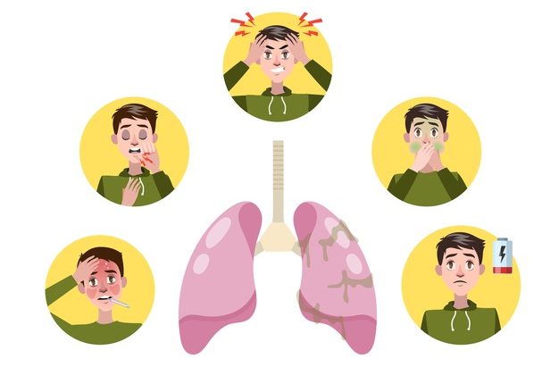Symptoms may include: cough, often called smoker’s cough. Coughing up mucus (expectoration). Wheezing and chest discomfort. Other symptoms may include: bluish fingernails, lips, and skin because of lower oxygen levels, wheezing and crackling sounds with breathing, swollen feet and heart failure.

To diagnose chronic bronchitis, your doctor will look for a productive cough (producing mucus) that lasts at least three months and happens multiple times over the course of at least two years. Tests used to diagnose chronic bronchitis include pulmonary function tests, chest X-rays or CT scans.

Chronic bronchitis is not curable but there are a number of treatments that can help you manage your symptoms. Bronchodilators, which relax the muscles around your airways. This helps open your airways and makes breathing easier. Most bronchodilators are taken through an inhaler. In more severe cases, the inhaler may also contain steroids to reduce inflammation. Oxygen therapy, if you have severe chronic bronchitis and low levels of oxygen in your blood. Oxygen therapy can help you breathe better. Pulmonary rehabilitation, which is a program that helps improve the well-being of people who have chronic breathing problems.

The best way to prevent chronic bronchitis is not to smoke or be around secondhand smoke. Avoid exposure to inhaled irritants and air pollution, stay away from others who have a cold or the flu, and wash hands frequently to prevent the spread of infection.

**Pneumonia**

Pneumonia is an infection in one or both lungs. The infection causes inflammation in the air sacs in your lungs, which are called alveoli. The alveoli fill with fluid or pus, making it difficult to breathe.

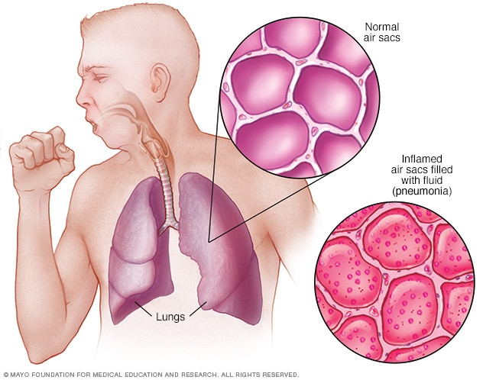Pneumonia may be caused by viral infections, bacterial infections, or fungi; less frequently by other causes. The most common bacterial type that causes pneumonia is Streptococcus pneumoniae. In the United States, common causes of viral pneumonia are influenza, respiratory syncytial virus (RSV), and SARS-CoV-2 (the virus that causes COVID-19).

The symptoms of pneumonia include; cough, which may produce greenish, yellow or even bloody mucus. Fever, sweating and shaking chills. Shortness of breath. Rapid, shallow breathing. Sharp or stabbing chest pain that gets worse when you breathe deeply or cough. Loss of appetite, low energy, and fatigue.

The diagnosis for pneumonia include the following tests:

Blood tests. Blood tests are used to confirm an infection and to try to identify the type of organism causing the infection.

Chest X-ray. This helps diagnose pneumonia and determine the extent and location of the infection.

Pulse oximetry. This measures the oxygen level in your blood. Pneumonia can prevent your lungs from moving enough oxygen into your bloodstream.

Sputum test. A sample of fluid from your lungs (sputum) is taken after a deep cough and analyzed to help pinpoint the cause of the infection.

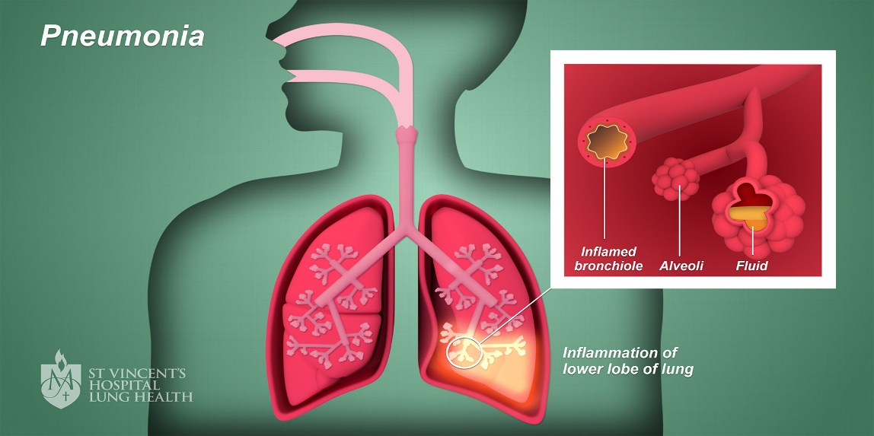

Specific treatments depend on the type and severity of the pneumonia, these include:

Antibiotics. These medicines are used to treat bacterial pneumonia.

Cough medicine. This medicine may be used to calm coughing in order for the patient to rest. Because coughing helps loosen and move fluid from the lungs, it's a good idea not to eliminate coughing completely.

Fever reducers/pain relievers. Taken as needed for fever and discomfort.

Some ways to prevent getting pneumonia are:

Getting the flu vaccine each year. People can develop bacterial pneumonia after a case of the flu.

Getting the pneumococcal vaccine.

Practicing good hygiene and not smoking